Library Management System
1. Introduction
1.1 Purpose
The purpose of this project is to design and verify a Library Management System using formal methods. The system manages books, users, issue operations, and return operations while maintaining system correctness through constraints and validation.
1.2 Scope
The Library Management System allows librarians and students to manage library resources efficiently. The system supports:
- Book issue operation
- Book return operation
- Book availability checking
- Validation of issued books
- Prevention of invalid system states
Formal methods such as Z notation, VDM, and Alloy are used to ensure correctness and consistency.
1.3 Objectives
The main objectives of the project are:
- To model a Library Management System formally
- To verify system correctness using formal methods
- To prevent invalid states using invariants
- To generate counterexamples using Alloy
- To maintain consistency through CI pipeline integration
2. System Overview
The system stores information about books and users. Books can either be available or issued to users. The system ensures that:
- A book cannot be issued to multiple users at the same time
- A book cannot be both available and issued simultaneously
- Only available books can be issued
- Only issued books can be returned
3. Functional Requirements
Requirement ID | Description
FR-1 | The system shall allow issuing books
FR-2 | The system shall allow returning books
FR-3 | The system shall maintain available book records
FR-4 | The system shall prevent duplicate issue operations
FR-5 | The system shall validate book states

4. Non-Functional Requirements
Requirement Type | Description
Reliability | The system should maintain valid states
Consistency | Data should remain logically correct
Maintainability | Project files should be version controlled
Verification | System should support formal verification
Security | Invalid states should be prevented

5. Users of the System
5.1 Librarian
The librarian manages books and performs issue and return operations.
5.2 Student/User
The user can borrow and return books.

6. System Constraints
The system follows these constraints:
- A book can only be issued if it is available
- A returned book must already be issued
- A book cannot exist in available and issued states simultaneously
- One book can only be assigned to one user at a time

7. Formal Methods Used
7.1 Z Notation
Z notation is used to define the system state, invariants, and operations mathematically.

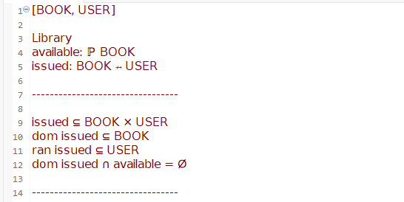
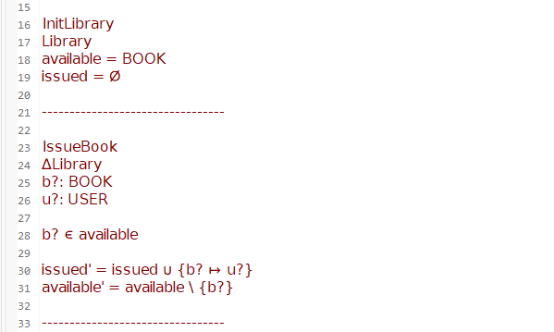
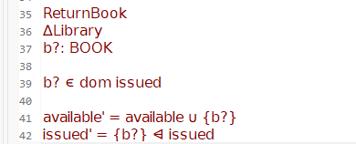
7.2 VDM Specification
VDM is used to specify system operations using preconditions and postconditions.
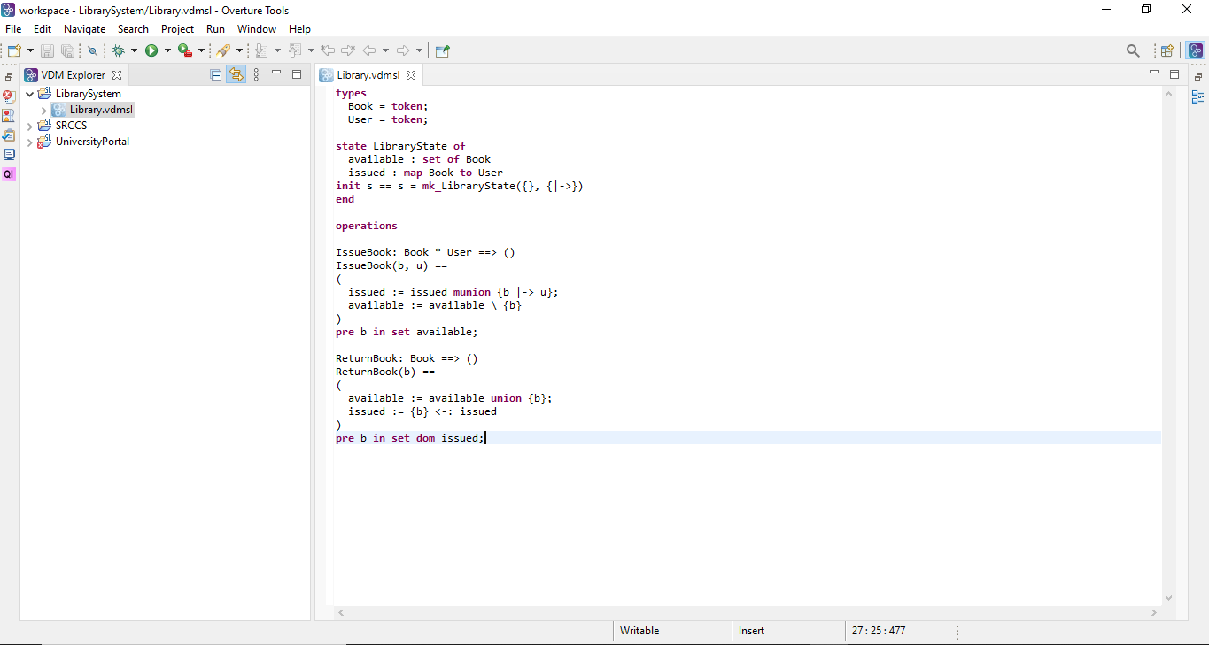
7.3 Alloy Model
Alloy Analyzer is used to validate the model and generate counterexamples.
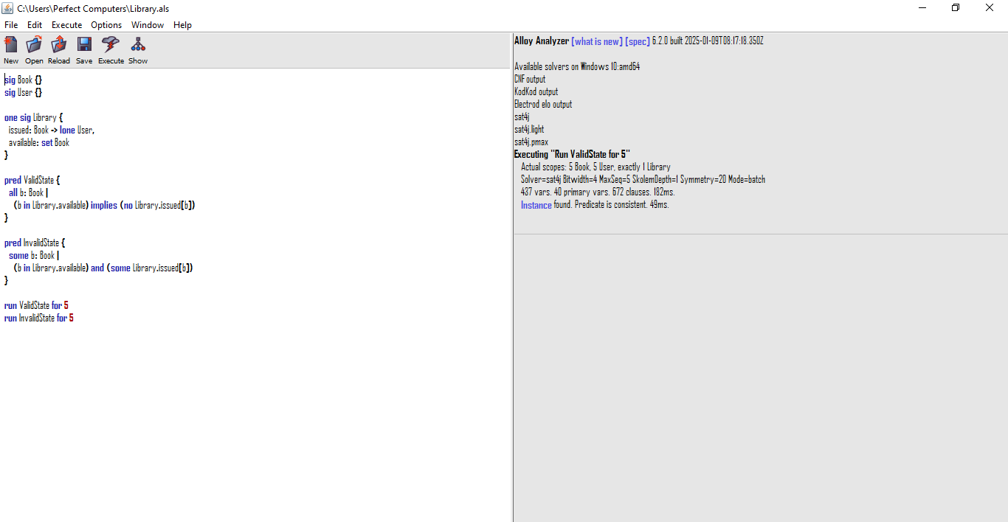
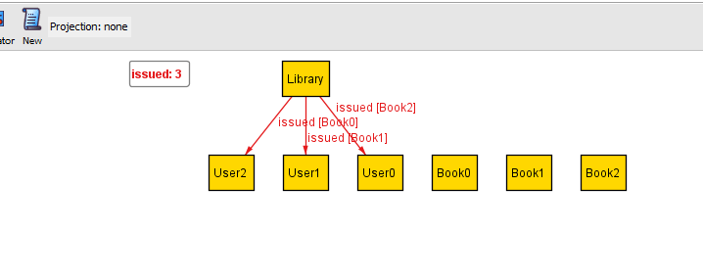
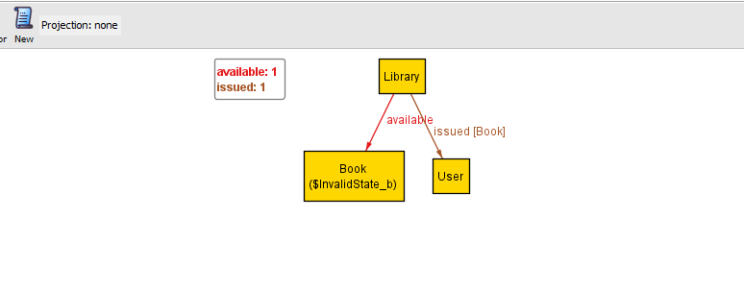
8. Validation and Verification
The system was validated using:
- Z notation invariants
- VDM operation checking
- Alloy counterexamples
- GitHub Actions CI pipeline
The Alloy model successfully generated invalid states when constraints were removed, proving the importance of invariants.

9. CI Pipeline
A basic CI pipeline was implemented using GitHub Actions.
The pipeline performs the following tasks:
- Checks repository files
- Maintains project consistency
- Supports version control management
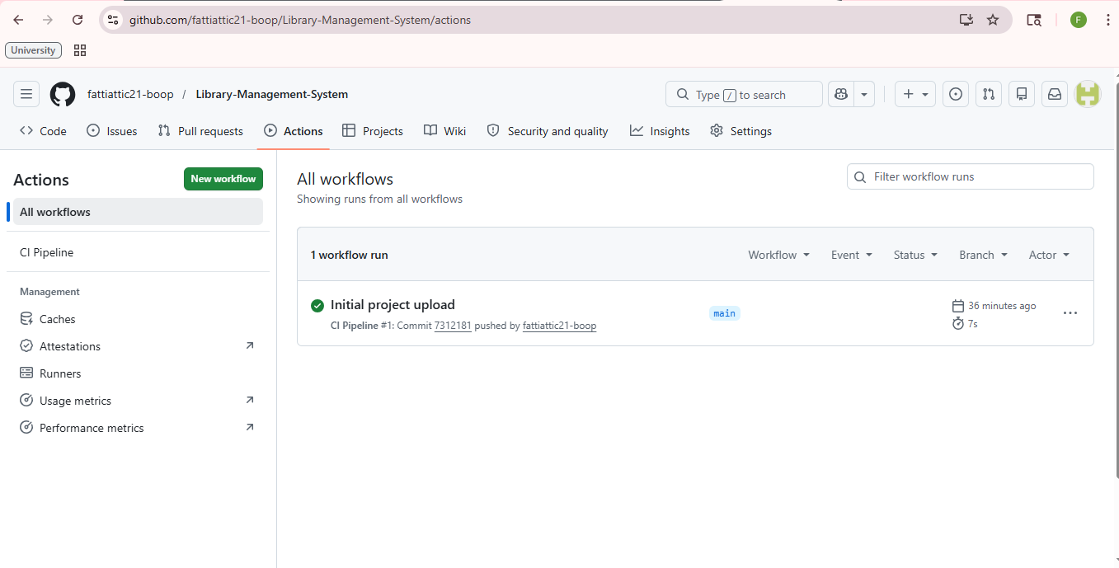
10. Requirement Defects
Requirement defects identified in the system include:
- Ambiguity
- Inconsistency
- Incompleteness
- Non-verifiable requirements
These defects were analyzed and documented to improve system reliability.
11. GitHub Repository
The complete project was maintained using GitHub for version control.

12. Conclusion
The Library Management System was successfully modeled and verified using formal methods. Z notation, VDM, and Alloy ensured logical correctness and prevented invalid states. The CI pipeline and GitHub integration improved project management and consistency.
The project demonstrates how formal verification techniques can improve software reliability and system correctness.
13. References
- Alloy Analyzer Documentation
- Overture VDM Tool Documentation
- GitHub Actions Documentation
- Formal Methods Course Material

